Telemarketing Campaign R code

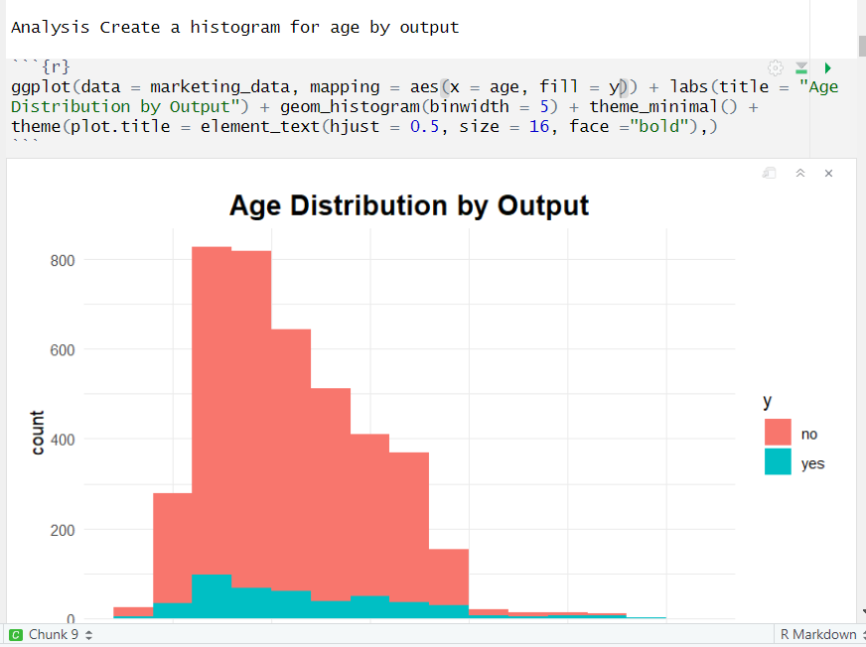
Age Distribution by Output (Histogram)

Code Explanation:
This code creates a histogram to visualize the distribution of customer ages, colored by their response (yes or no) to the telemarketing campaign.
Outcome:
Most customers are between 25-50 years old, with a higher proportion of non-responders (no), but some positive responses (yes) appear in all age groups.

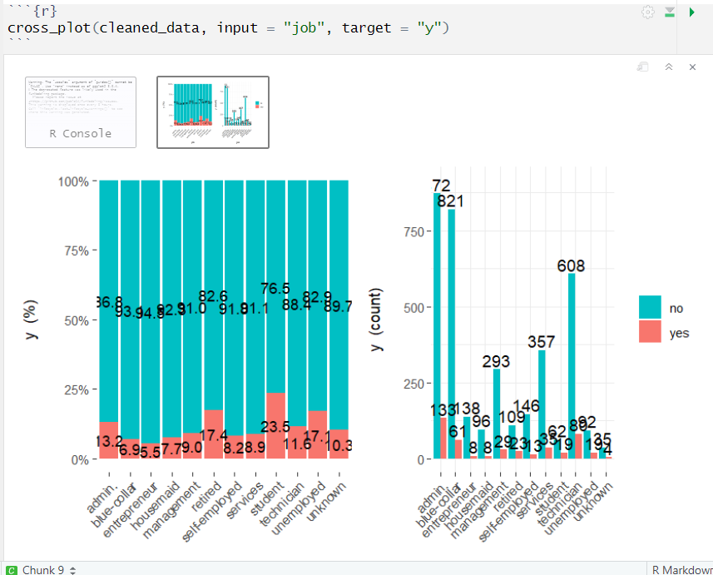
Job Distribution by Campaign Response

Code Explanation:
This code creates a histogram to visualize the distribution of customer ages, colored by their response (yes or no) to the telemarketing campaign.
Outcome:
Most customers are between 25-50 years old, with a higher proportion of non-responders (no), but some positive responses (yes) appear in all age groups.

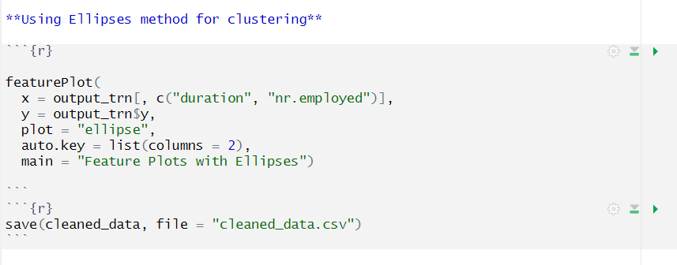
Clustering with Ellipses Method

Code Explanation:
This code uses ellipses to visualize relationships between call duration and employment rate (nr.employed) based on response (yes or no).
Outcome:
Longer call durations significantly increase the likelihood of a positive response, showing that engaged conversations improve success rates.

k-Fold Cross-Validation for Logistic Regression
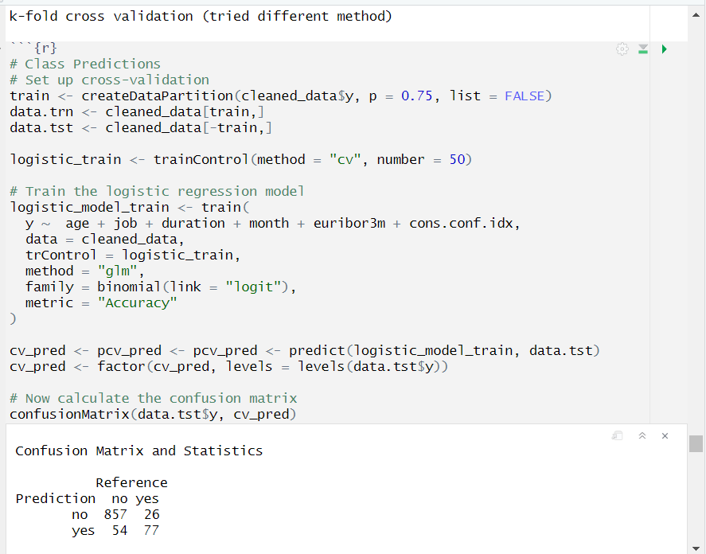

Code Explanation:
This code performs 50-fold cross-validation on a logistic regression model to predict customer responses using multiple factors like age, job, and call duration.
Outcome:
The model is fairly accurate, correctly predicting most "no" responses, but it misses some "yes" responses, indicating a need for further improvement.

Detecting Outliers in Age Distribution (Boxplot)
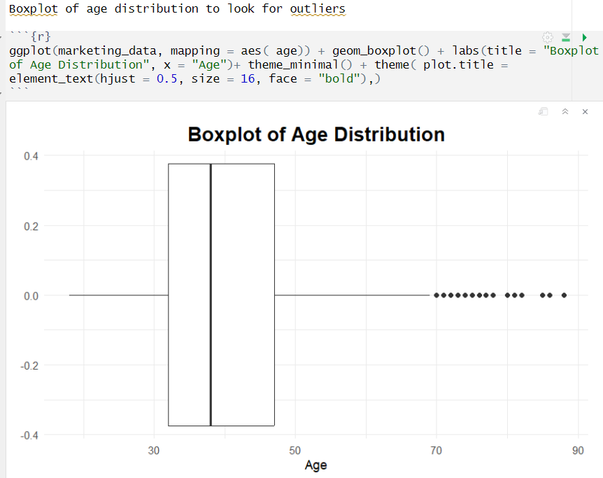

Code Explanation:
This code creates a boxplot to identify outliers in customer ages.
Outcome:
The majority of customers are 30-60 years old, but some outliers (70-90 years old) exist, which might need special handling in analysis.

Optimal Number of Clusters for Customer Segmentation (Silhouette Method)

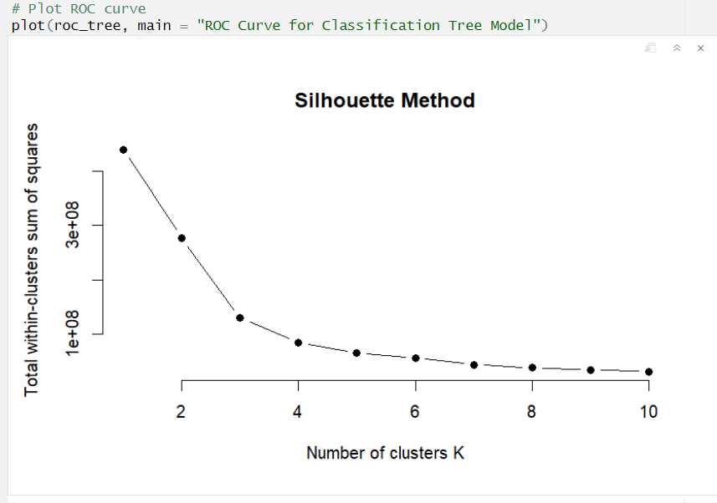

Code Explanation:
This code uses the silhouette method to determine the optimal number of clusters (K) for customer segmentation.
Outcome:
The elbow point at K = 4 suggests that 4 clusters are ideal, helping in better-targeted marketing campaigns.

